Excel Assignment – 15

1. Create a Pivot table and show what the main export product is?

Ans-

Scale is the main product

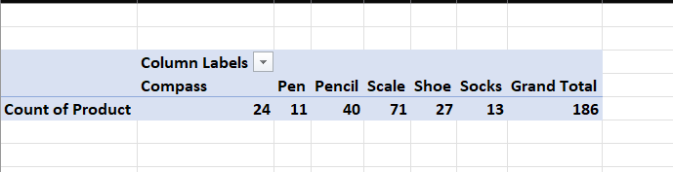

1. Create a bar graph showing the amount spent for each product?

Ans-

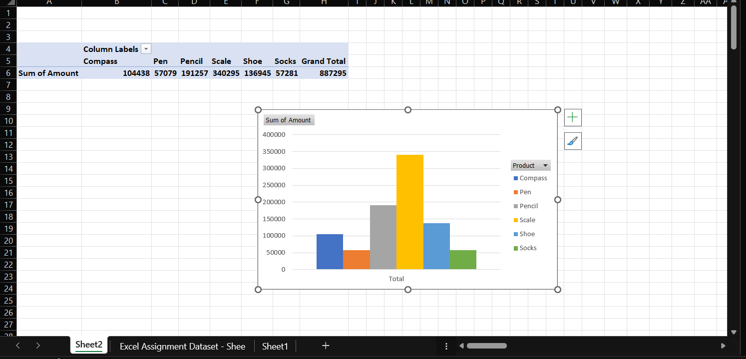

1. Create a Pivot table to show The sales in each city.

Ans-

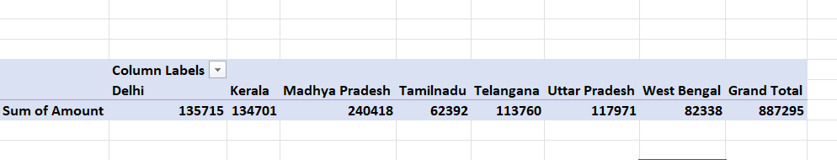

1. Create a chart showing the amount spent for each product in each city.

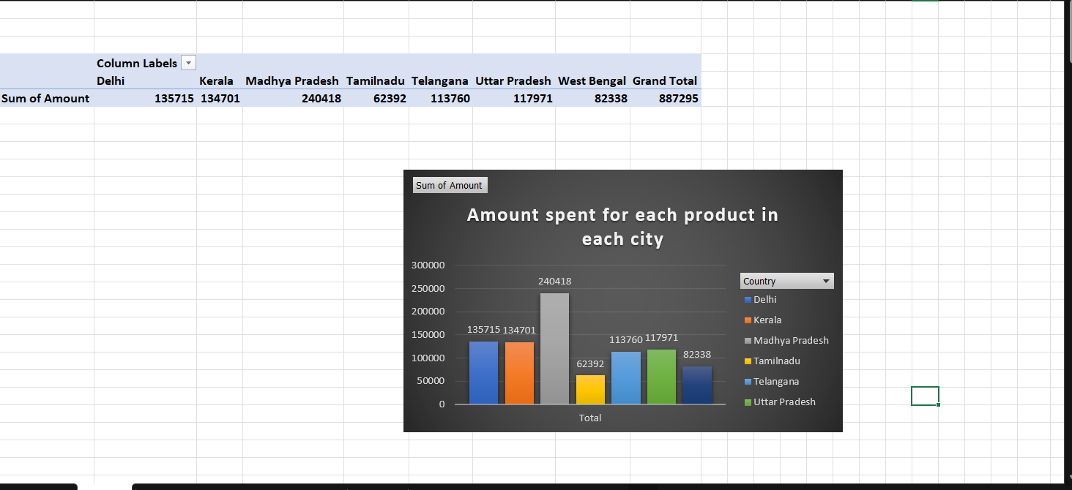Ans-